What Being a Black Belt Means to Me

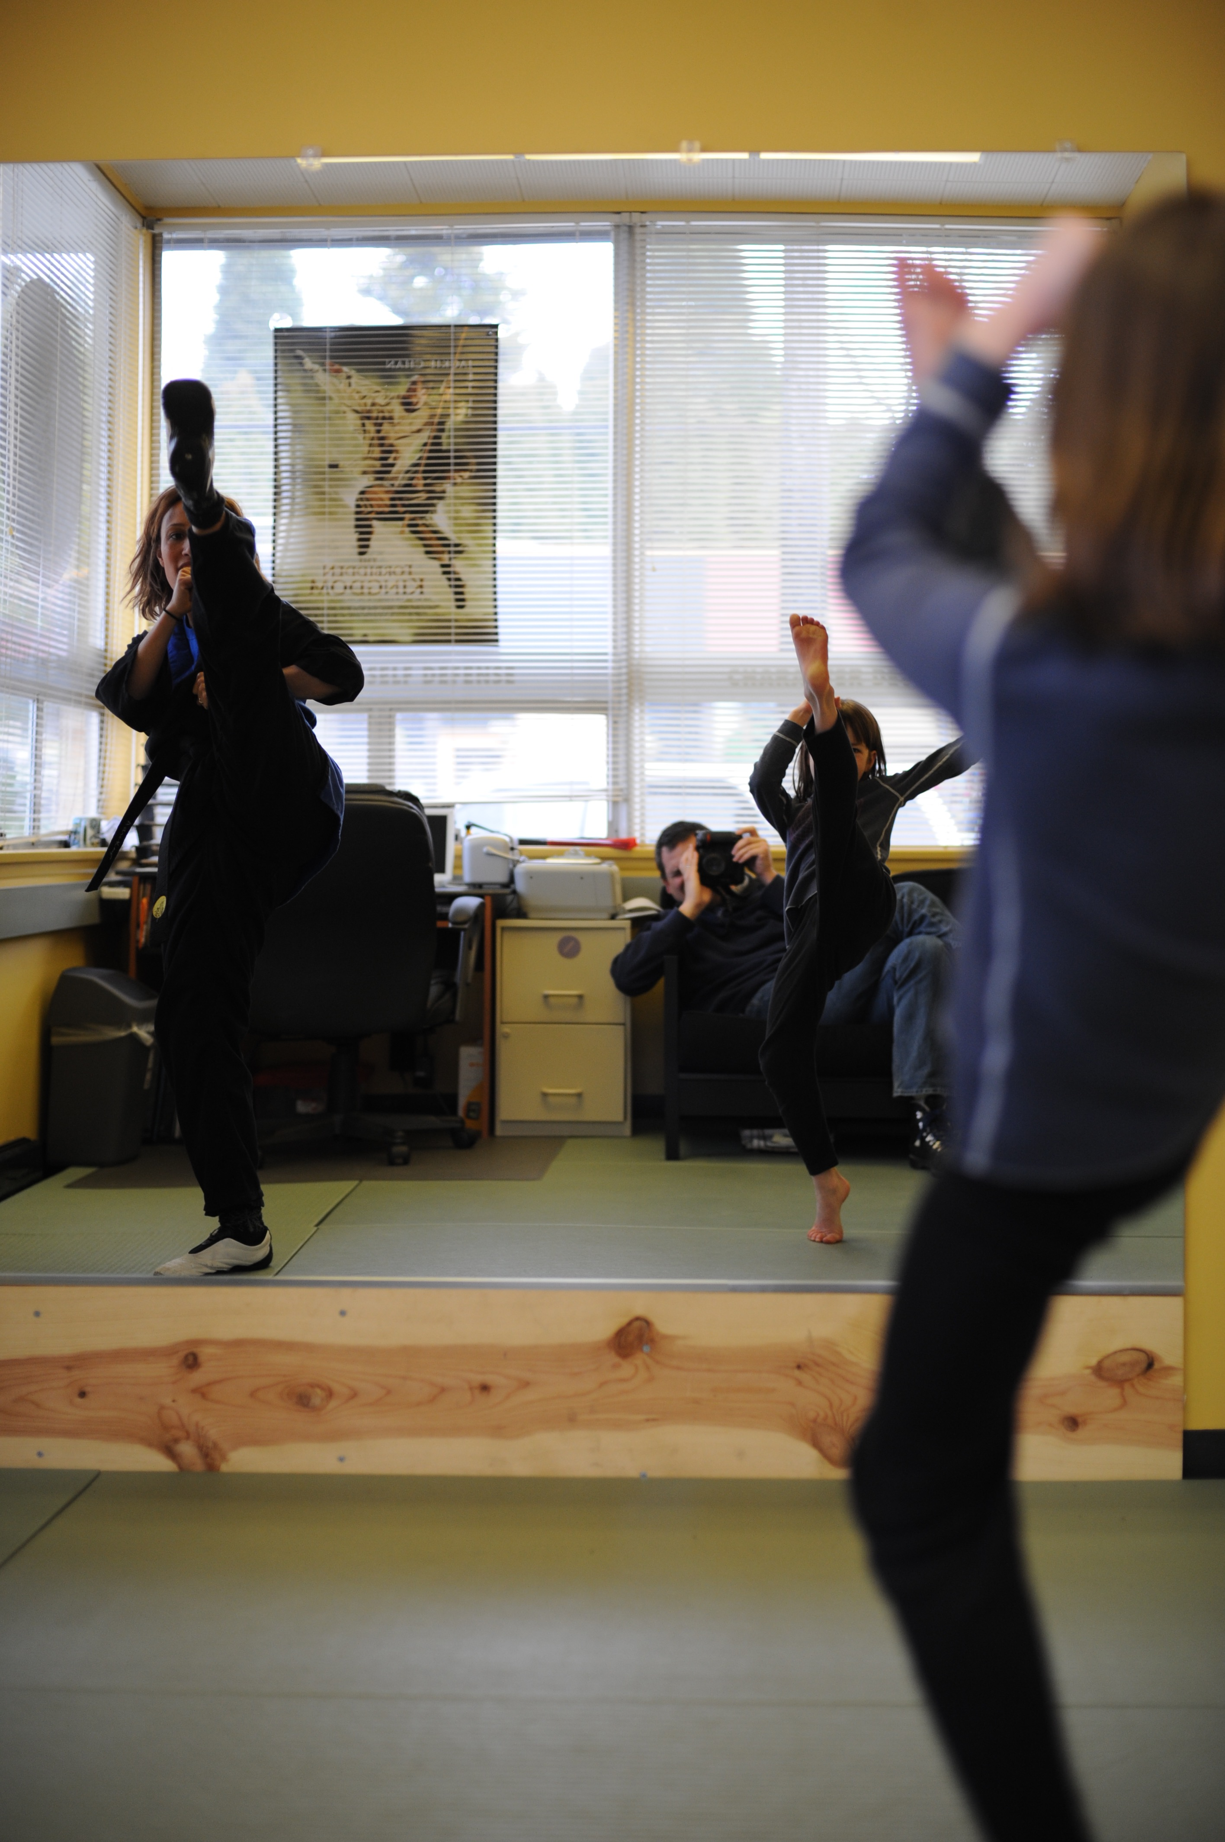
Being a black belt is an experience that has changed my life so fundamentally that I can hardly name all the impacts it has had on me. It’s like trying to picture a scrapbook with pages ripped out, and all the colors muted. So instead of trying to map the entire night’s sky in one image, I turn to the stars to show my journey, individual pinpoints forming constellations that serve as a guide through my universe of stories.
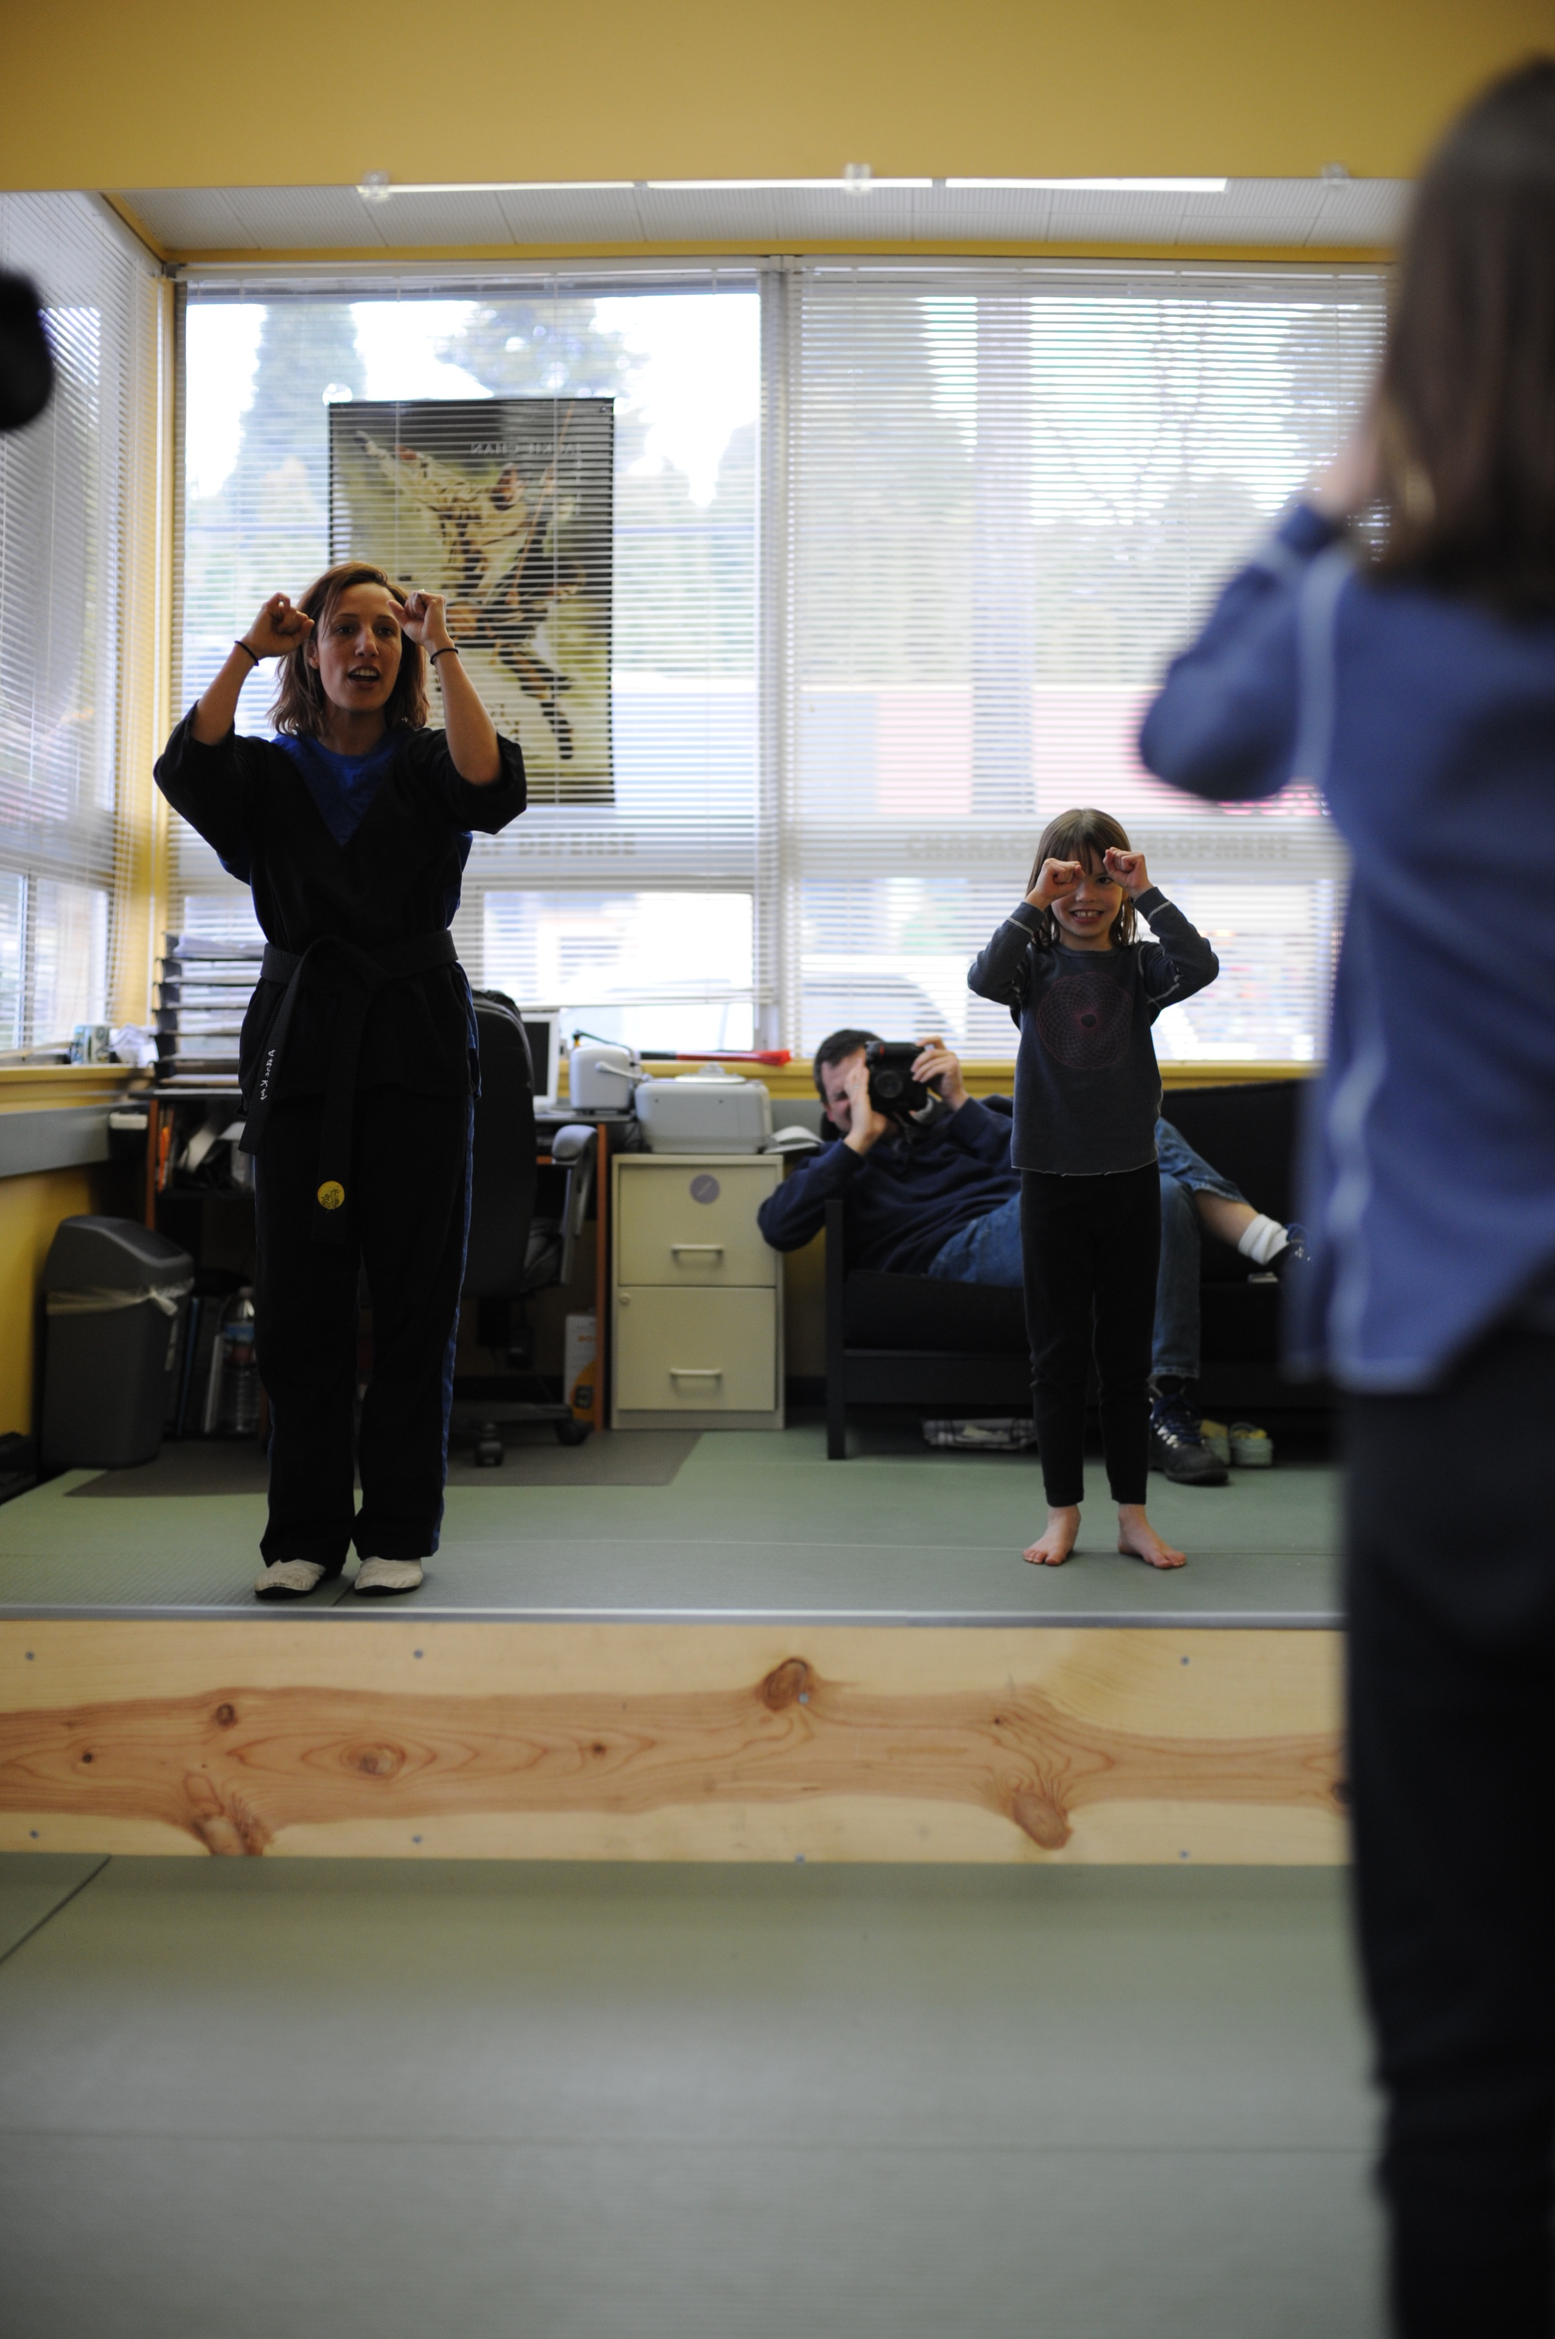
I have a folder on my phone that I’ve tried to fill with every martial arts photo I could find since my very first karate class in the spring of 2008. Though I was not yet a black belt, I feel it is important to begin here, at the start of my journey. I find it miraculous to reflect on the child that I was, with messy bangs and a gap-toothed grin, doing my utmost to mimic my instructor’s snappy punches and kicks, back when orientations were still held on miniature mats in the manager’s office. When my mother signed me up for that first lesson, I am sure she only hoped I would enjoy it, that maybe karate would provide an outlet for her daughter-shaped ball of energy and emotion to structure her spirit. She certainly didn’t picture having not one, but three children become black belts, nor that eleven years later, I would still be bounding into that lobby, often six days a week. Yet somehow, I now have the chance nearly every week to guide kiddos through their own first lesson, see the spark in their eyes as they realize the power hidden within their own two feet and fists. I get to help begin their martial arts journeys, just maybe planting a seed in their lives that will someday become a forest.
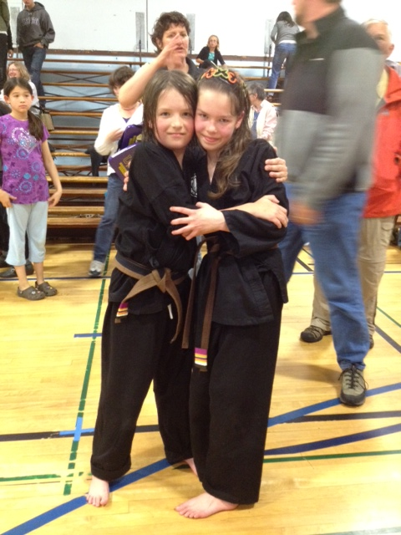
Flash forward several years, and I was twelve, growing out my bangs but still with my characteristic smile. I was at the age where invincibility and vulnerability cautiously mingle, and about to face my first major martial arts challenge: when I tried to test for my junior black belt, I failed. It was one of my first encounters with failure of that magnitude, and though at the time I was devastated, I realize now how important that failure was. The second time through the prep cycle, I understood success wasn’t a given. I was far more dedicated, more motivated, and put in the time and effort I hadn’t before. My junior black belt test caused me to reconsider why it was that I trained. It taught me the power of perseverance, of forging forward even when the journey was hard, the path strewn with barriers. I love the picture of my brother and I at the end of our first day of testing because I think it encapsulates this experience. Both of us look a mess: exhausted, pushed to our limits, but happy. Victorious. Strong.
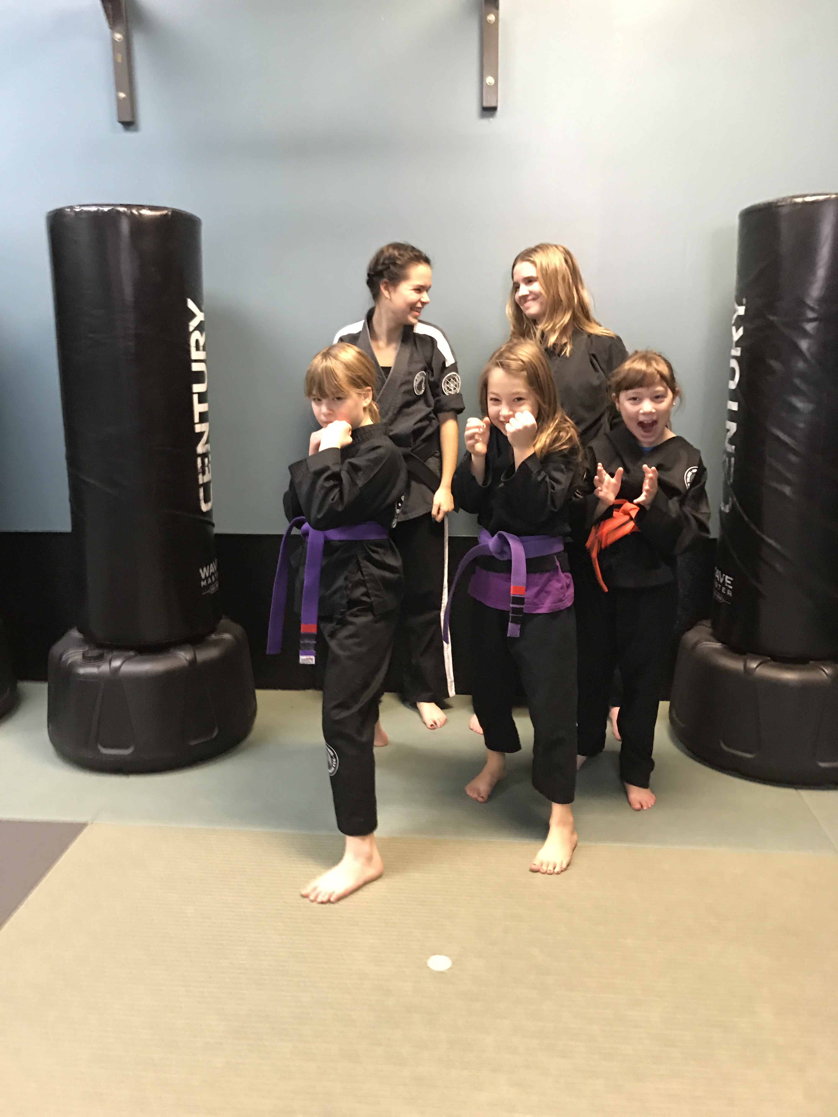
Growing up a girl, my black belt was a particular source of pride for me. Though our dojo is so much better than most in terms of fostering female students, I still remember many a class over the years where I was one of few if not the only female present. Yet somehow, this never deterred me. I have never let my gender limit my experiences, and to this day I try to hold myself to the same standards as the men around me, regardless of whether I actually succeed. I try to be technical where I lack in size or muscle, and rely on effort wherever I can. One of my favorite training memories was throwing some of the teenage boys I trained with into Wavemasters practicing “Taming the Mace” after they were reluctant to throw me, proving to them and myself alike that I wasn’t breakable. Even though I am rarely the strongest or biggest when I train, my black belt is proof to me that I am capable. My black belt reminds me that wherever I go in the world, I can hold my own and stand up for myself and help others to do the same. I love this picture because it reminds me of all the wonderful women who have inspired me and who I hope to inspire, and the strength and empowerment that together, we can create.
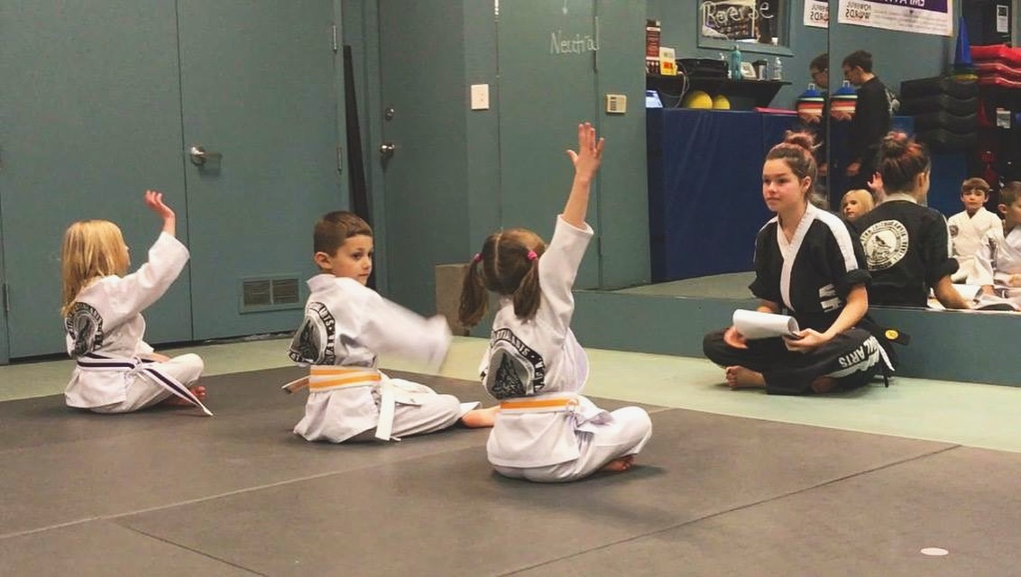
Both before and after earning my black belt, many of the memories that stand out to me relate to leadership. In true oldest-child fashion, I joined STORM team the moment I was eligible, and eagerly anticipated the day every week where I got to help out in classes. As much as I initially (and even still) enjoyed the chance to boss people around, my confidence growing with age and skill, it became more and more clear to me over the years why leadership actually mattered. I saw myself reflected in the faces of these children, first the ones I volunteered with, and then the students I taught. I began to understand the skills that martial arts had given me. Through karate, I learned to temper my confidence with courtesy and modesty. I learned the self-control my mother was so desperate to teach me. I learned how kindness is just as important to the culture of martial arts as strength or speed. And I learned how important it was to me to share these lessons with others. Maybe this was why I latched on so fervently to Mat Chats when I started teaching: they seemed to me an opportunity to pay forward the wisdom I had gained. In the picture above, I am leaning forward, delighted and eager to hear what my students have to share. As a black belt and leader, I hope to help foster a kinder world, one child at a time.
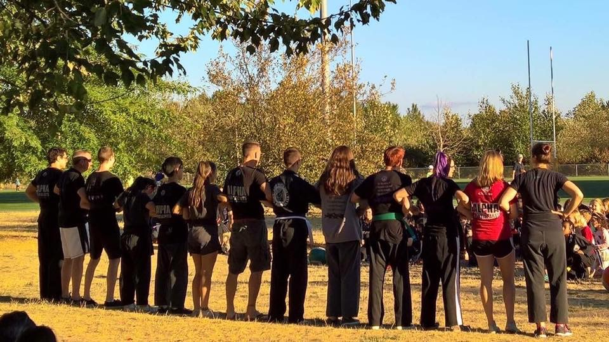
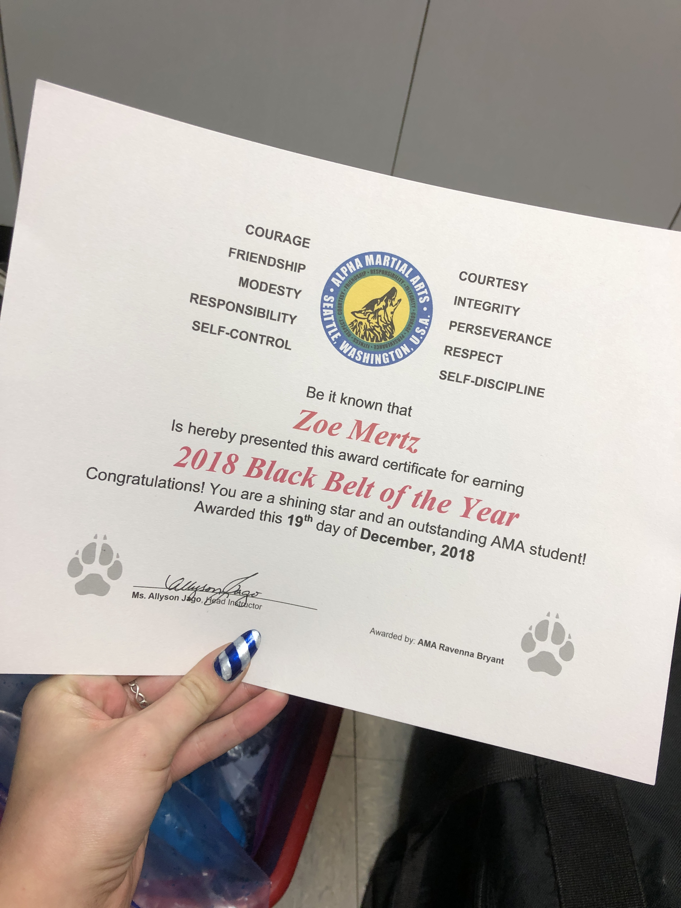
Whenever I am asked about my job, about the place where I spend so many evenings and weekends, I always feel my face light up. Being a black belt means being part of a family and community that is bigger than myself, a place where I am always welcomed. I love the coworkers and friends I’ve gained in my time training. I love encouraging my students on their quest to succeed. I was absolutely honored to be recognized as Black Belt of the Year in 2018, a title I strive every day to deserve. I received this award in the midst of Winter Camp, one of my biggest challenges to date as an instructor, and this simple act motivated me to push forward. The impact this recognition had for me reminded me of the power of praise, of reminding the people around you every day of their value. It also reminded me that as monumental an achievement as earning a black belt is, being a black belt is about grand actions or gestures. I think that being a black belt means working hard every day to be the best that I can, on the mats and off. I don’t think this has to happen in a big way. If every day, I can be a little better, and a little better, and maybe help someone else do the same… that’s what it means to change the world. One black belt at a time.

Community Service

For my black belt community service, I participated in a program through UW Honors helping admitted students learn about UW and decide whether they wanted to commit. I volunteered at several different events alongside fellow student volunteers and our Honors advisors, including a student information session, acting as a student representative to answer questions, and an event called the Honors Hearth, checking in students and families and assuring that everyone felt welcome. My name was also added to an online database of current UW Honors students, along with my contact information, so that prospective students could get in touch with me. Finally, I was given a list of admitted prospective students to correspond with, each of whom I emailed welcoming them to UW, offering to answer questions, and assuring them that any college decision that they made was an excellent one, so they shouldn't feel pressured or worry. Though it is hard to quantify the amount of time spent on individual email responses and such, the events lasted approximately four hours altogether.
I found this project particularly meaningful having just gone through the stressful process of applying and committing to college myself. I remember feeling overwhelmed and confused, unsure of what I actually wanted. I was happy to be able to pay forward the help and guidance I was offered during this time. I hope that in volunteering my time and sharing my experiences, I was able to quell at least a few of these nerves for this next round of students.
Book Report

For my book report, I read Don’t Sweat The Small Stuff, by Richard Carlson. This book consisted of a collection of one hundred brief tips and lessons about how to live a more peaceful and stress-free life. I appreciated the format Carlson chose to structure this book, as I found it a very clear and manageable way to present the material. I also appreciated one of the book’s central goals of encouraging readers to live a kinder and gentler life. I think that this is such an admirable, important mission. I am a firm believer in the power of kindness.
The wonderful thing about having so many lessons and examples is that one of these is bound to speak to readers. As I read, I found myself marking the pages of lessons that particularly spoke to me, either because they contained tactics I already try to employ in my life, or because they described strategies that I felt I could definitely work on. For example, one lesson I already try to practice was #46: Every Day, Tell At Least One Person Something You Like, Admire, or Appreciate About Them. This idea ties into my eternal love of Good Job Notes! I think that giving people compliments is one of the simplest acts of kindness to perform, and yet also one of the most powerful. Taking a moment – just one moment – out of your day to make someone else feel good is such an easy thing, with such a meaningful result. A strategy I feel I have begun to implement but could still work on was #36: See the Innocence. This strategy encourages readers not to judge the character of someone who is behaving in an irrational, mean-spirited, or frustrating way, but rather view them as an innocent in need of help and compassion. This strategy is already one I tend to employ in my teaching (for better or worse), but I want to strive to include it in my daily life as well. A strategy I had not thought about before that I definitely think I should incorporate into my life was #55: Breathe Before You Speak. I am someone who loves to talk and tends to dominate conversations. This strategy seems an extremely simple way by which I can work to become a better listener, and therefore more kind and considerate of those around me.
One problem I found with Carlson’s book was the fact that it became slightly repetitive in order to include one hundred distinct lessons. I felt that if Carlson was not so set on that round number, his anecdotes and segments might have been more consolidated, so that I didn't feel at the end like I’d read the same sets of advice over and over. That being said, I also do not feel that reading this book straight through is the method that lends itself best to the text. If I were to read this book again (which I might! It had some good lessons) or recommend it to someone else, I would suggest reading a chapter or so every day over time. I feel that this would make the material more digestible. It would also give readers the opportunity to put into practice each day the lesson that they read.

