Image source: https://www.williamiveylong.com/chicago.html
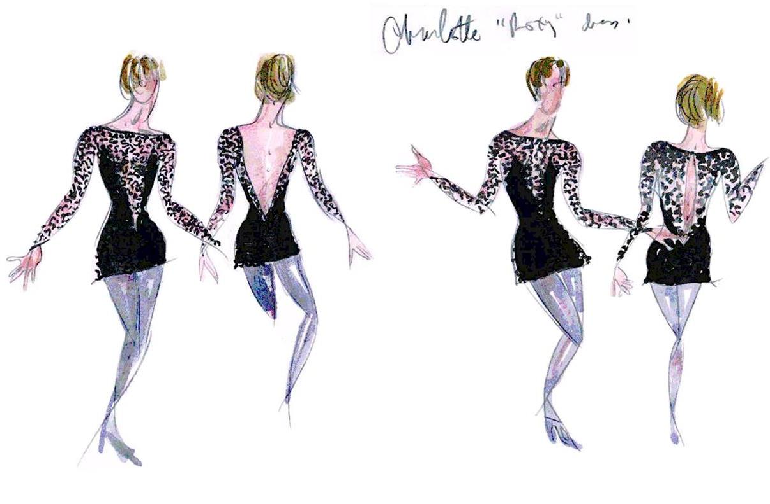
Costume designer William Ivey Long’s sketches for the outfit of Roxie Hart

Actress Melanie Griffith models Roxie’s costume, from designer William Ivey Long’s online archive.

Image source: https://www.williamiveylong.com/cameron_museum.html

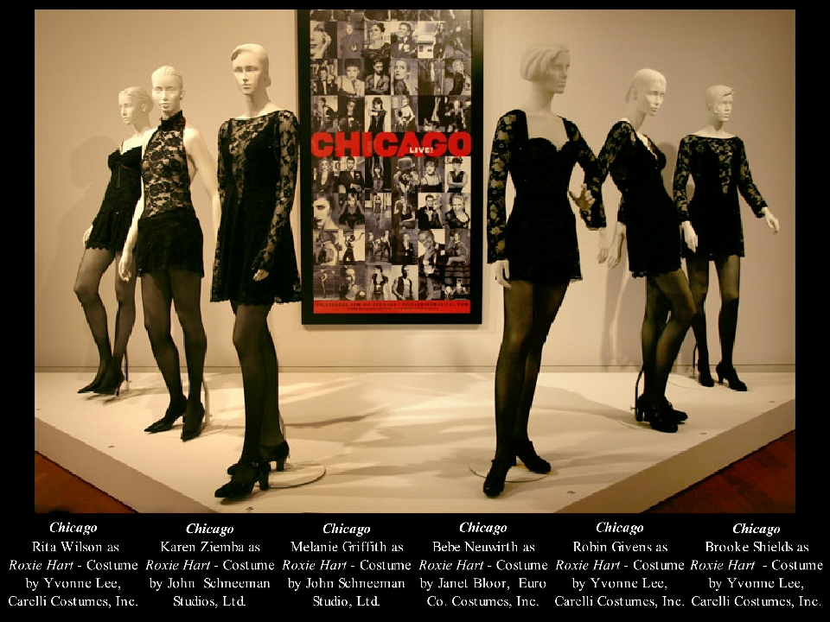

Variations on the costume of Roxie Hart worn by different actresses over the years, from the online archive of William Ivey Long’s Cameron Art Museum exhibit William Ivey Long: Between Taste and Travesty, displayed in Wilmington, North Carolina from April 28, 2007 through October 14, 2007.

